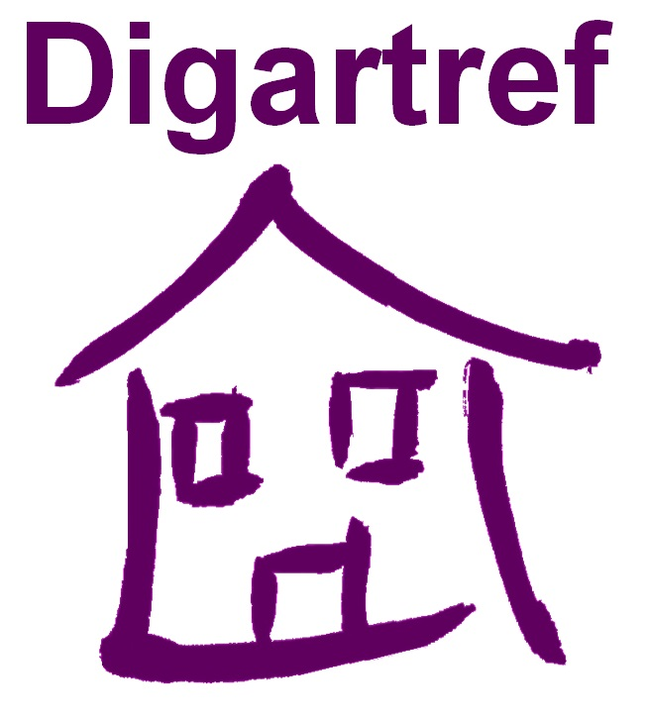

Job Description

Job Title: Supported Housing Projects Manager
Responsible To: CEO
Location: Holyhead, Anglesey
Grade: Pt 31 – 33
Salary: (£28,694.37 - £30,412.18) plus on call payment
Hours of Work: 37 hours per week plus managers on-call every 4 weeks. Mainly Monday to Friday with some flexibility if required from time to time.

Purpose of your job

- To be responsible for the day to day management of Supported Housing Services in and around the North of Anglesey, which include a 9 bed, 24 hour staffed hostel for young people aged 16 to 24, a range of self-contained properties as well as floating support service, plus any other as developed. Ensuring the provision of a high quality service and compliance with the aims of the Housing Support Grant and related service specifications.

- To provide day to day support and supervision to staff in all aspects of their work, ensuring staff are familiar with and work within the company’s policies and procedures as well as the overall aims of the services.

- To ensure the delivery of an effective housing management service, including tenancy/licence agreement administration and compliance, void and rent arrears control, maintenance and repairs, furniture replacement, utilities control, compliance with related health and safety issues including fire evacuation procedures and alarms and comprehensive reporting.

- To work and liaise closely with a range of external agencies including funders and other stakeholders, ensuring a holistic multi-agency approach is adopted in the delivery of the service.

1. Staff Management

  - To be involved in the recruitment, selection and induction of staff in line with the companies recruitment polices and procedures.

  - To provide day to day support, regular supervision and annual appraisals, ensuring staff are familiar with and work to the company’s policies and procedures and overall aims and objectives. This will include the facilitation of regular recorded staff meetings, individual 1 to 1 management support meetings, probationary period reviews and capability and sickness absence management.

  - To be responsible for monitoring the staff team’s performance, ensuring a professional attitude to work, compliance and adherence to the Staff Code of Conduct at all times, dealing effectively with poor performance, and where required, assist in the investigation of complaints including grievances and disciplinary cases in line with company’s related policies and procedures.

  - To be responsible for the planning and coordination of the team’s workload, including and ensuring 24/7 staff cover at all times via compilation of a staff rota and arranging cover for absent staff.

1.5 To operate within the legal practice framework with regard to employment legislation and the companies related policies and procedures.

1.6 To assist in identifying the training needs of the staff team, working to a budget to source training required in line with the companies related policies and procedures.

2. Housing Management

2.1 To ensure related tenancy and licence agreements are issued correctly and service users comply with the terms of their tenancy agreement. Where breaches occur that the related companies policies and procedures are followed.

2.2 To maintain void and rent accounting tracking systems at project level in order to monitor rent payments, control related bad debts, ensure high occupancy levels.

2.3 To ensure the delivery and coordination of a high quality, effective housing management service, to include maintenance and repairs to the building, fixtures and fitting, heat and lighting systems and all external areas, furniture replacement, utilities control, compliance with related health and safety issues including fire evacuation procedures and alarms and comprehensive reporting.

2.4 To ensure best value and quality at all times in sourcing contactors to undertake all related maintenance, repair and servicing work required (fire alarm and PAT)

2.5 To ensure service user accommodation, communal and staff allocated rooms and offices as well as all external areas comply with all Health and Safety, Environmental, Fire and other regulations (food hygiene)

2.6 To ensure all accommodation, including external areas, are cleaned on a regular basis and that high standards of hygiene are maintained at all times.

2.7 To be fully conversant with the defined housing management targets, ensuring these are adhered to and achieved and where problems are identified to report to the CEO on a regular basis, setting targets and actions for improvement

3. Support of Residents/Service Users

3.1 To be responsible for ensuring a high quality tenancy related support service for those accessing the provision, in line with the aims of Housing Support Grant objectives in Wales.

3.2 To ensure all related procedures and processes are followed, including the undertaking of risk and needs assessments, support planning and related reviews.

3.3 To be actively involved in the interview, selection and risk management of potential service users in accordance with the companies policies and procedures.

3.4 To ensure the service users rights to privacy, dignity and self-determination are promoted, and that their rights as citizens are upheld.

3.5 To actively encourage service user participation and involvement in the delivery and further development of services including:
- Ensuring the staff team hold regular resident/service user meetings that minutes are taken and actions identified are addressed, completing service user satisfaction questionnaires, adhering to the organisations Service User Involvement, Complaints & Compliments and Equal Opportunities policies and procedures.
- Supporting service users to be actively involved in their community, ensuring they have a voice and an opportunity to be heard/take part.

4. Working with others

4.1 To ensure professional close working links/relationships are forged and maintained with related stakeholders, funders, referring agents, contractors, neighbours etc.

4.2 To attend external meetings as agreed or requested by the line manager,

4.3 To attend and facilitate internal meetings as requested including: team staff meetings, managers’ meetings, annual staff meetings and others as required.

4.4 To foster and maintain professional, positive working relationships with other Digartref Cyf staff members, working closely to optimise the benefits and opportunities for service users and create and maintain a supportive work environment for all staff across the company.

5. Use of I.T

5.1 To have a working knowledge, understanding and practical experience of I.T packages i.e. Microsoft Office, e-mail, outlook. The ability to work with specifically adapted internal systems e.g. Genesis

6. Financial Management and Administration

6.1 To ensure all administrative tasks are carried out, including that of the team, and that all statistical data is collated, reported on in a timely manner, meeting all related deadlines that all reports required by funders, stakeholders, senior management and the Board are completed to a high standard.

6.2 To assist in setting annual budgets for the services you manage and to take lead responsibility for managing these, monitoring performance and ensuring spend is contained within the agreed limits and that accurate up to date petty cash, service user personal payments and other financial records are maintained, taking corrective actions as appropriate.

6.3 To record, collate and sign off salary and staff travel claims information and submit to Admin and Finance Dept. within the required time scale.

6.4 To ensure maximum rent collection, including supervising support staff in ensuring accommodation charges are collected from residents, Housing Benefit applications are completed and submitted promptly and residents personal charges are collected weekly. Rent and service charge payments received need to be monitored weekly to prevent rent arrears from impacting on the individual as well as the financial viability of the project.

6.5 To ensure that high occupancy levels are maintained at all times and to prevent any unnecessary delay in filling vacant bed spaces in order to minimise the impact on service users and the financial viability of the project.

7. Health and Safety

7.1 To ensure the health and safety of oneself, the service users, the staff team, work colleagues as well as other external visitors/ contractors visiting the project at all times.

7.2 To lead on the health and safety issues within your team/services on a day to day basis. Undertaking periodic and annual health & safety checks as directed by the CEO, working closely at all times with Digartref Cyf’s Health & Safety consultants to address recommendations and actions required to ensure compliance.

7.2 To comply with Health and Safety requirements and related policies and procedures at all times e.g. risk assessments, reporting procedures, and on-call. That regular security and health and safety checks are carried out at the projects and related reports are compiled and further actions identified are carried out.

7.3 To ensure the building is secure at all times and that related access procedures are adhered to.

7.4 To ensure a clean and safe working environment at all times

7.5 To have a flexible approach to working hours in order to respond to emergency situations in accordance with Digartref’s policies and procedures.

8. Safeguarding

8.1 Will have a shared responsibility for the coordination and reporting of Safeguarding issues within the organisation and will be required to act as a Designated Officer and main contact for staff and service users in relation to Child Protection, POVA and Domestic Violence

9. General

9.1 To adhere to the organisations Staff Code of Conduct at all times.

9.2 To adopt a flexible approach to working, which may include covering the rota in occasions in the absence of the staff team and to regularly cover the Managers on-call rota on a 4 week rolling basis (for which additional payments will be made) in order to meet the needs of the service and provide additional support to staff.

9.3 To participate fully in the organisations supervision/management support and appraisal process.

9.4 To attend/take part in training and development opportunities as requested/identified by the line manager or other senior managers within the organisation.

9.5 To work independently and as part of a team and liaise effectively with other projects and staff.

9.7 To adhere at all times Digartref’s Policies and Procedures.

8.8 To perform any other reasonable task as determined by the CEO and Board of Trustees.

8.9 The ability to communicate effectively through the medium of Welsh and English or a willingness to learn.

This job description covers the current range of duties and will be reviewed from time to time. It is Digartref Cyf’s aim to reach agreement on changes, but if agreement is not possible, Digartref Cyf reserves the right to change this job description with appropriate notice.
Supported Housing Projects Manager

 | ESSENTIAL | DESIRABLE
EXPERIENCE  &  QUALIFICATIONS | - An appropriate qualification in Housing/homelessness, Youth & Community, Leadership & Management or Social Care or at least 2 years related work experience.  - Experience of Management/support of staff.  - Experience of providing services for vulnerable people with complex support needs. | - Experience of housing management related duties e.g. tenancy law, void control.  - Experience of financial management/budgeting responsibilities.
SKILLS  &  KNOWLEDGE | - Working knowledge of homelessness issues.  - Excellent organisational and communication skills, with the ability to prioritise the workload and meet deadlines.  - Excellent computer/IT skills.  - Excellent verbal and written communication skills.  - Practical problem solving skills and the ability to make decisions under pressure while dealing with difficult and emergency situations.  - Understanding of confidentiality and knowledge of Equal Opportunities  - Awareness and understanding of relevant health and safety legislation and related issues. | - Knowledge of The Housing Support Grant in Wales as well as homelessness legislation.  - Working knowledge of Welfare Benefits  - A working knowledge and understanding of Safeguarding as it relates to Child Protection, POVA and Domestic Abuse
Abilities | - Ability to prioritise own work and that of the team.  - Ability to forge and maintain effective working relationships and partnerships with external organisations and key stakeholders. | - Ability to undertake presentations to various audiences
Attitude | - Empathy and understanding of issues relating to young people with complex needs and those affected by homelessness.  - Non-judgmental, non-discriminatory approach, being helpful and approachable.  - Ability to maintain professional boundaries/relationships with service users at all times.  - A commitment to your own personal development and that of your team.  .
OTHER | - A full and clean driving licence and access to own vehicle; business use insurance cover.  - The ability to communicate in Welsh and English or the commitment to learn.

